# Air University Islamabad Logo Clipart , Png Download - Air University ...

Agent Based Software Engineering

Activity

Name : Muhammad Shamoil  
Registration ID : 232025  
Section : BSSE - V – A  
Submitted To : Sir Anwaar

# Upgraded Automatic Door

# Enhanced Traffic Light

# Smart Street Light

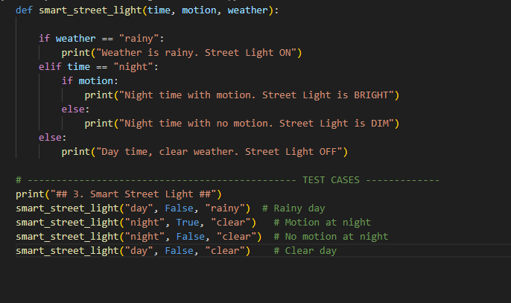

# 4. Extended Temperature Control

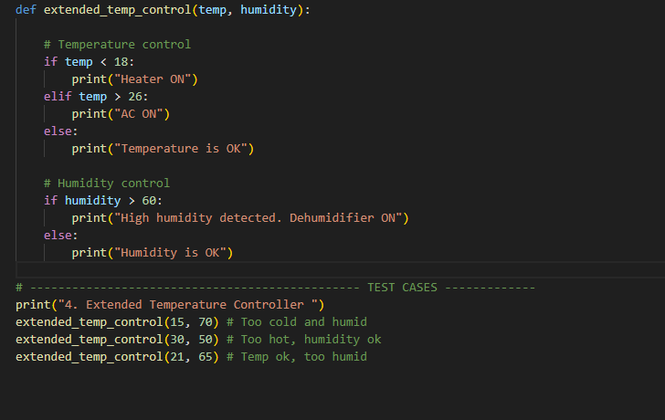

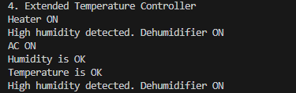

# 5. Extended Sanitizer Dispenser

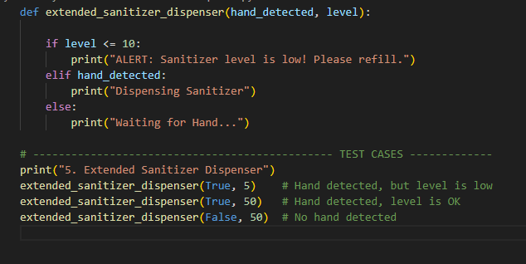

# 6.Extended Seat belt Alarm

# 7. Extended Smart Thermostat

# 8.Extened Water Tank

# 9.Extened Battery System

